**BlackBox 2**

1. First, when I opened the folder I realized that there are 2 files which should be extracted but I don’t have their password so may I find them in the next stages.
2. Second, I tried to open the image file **secret.png** using a basic images program(like **Photos** on windows platform) but the file didn’t open.
3. Then I opened the image using hex editor (I used **HxD**) and found out that the **magic number** of the **png** format file was wrong, so I changed it to the right one and it worked! You can see that in the following image:

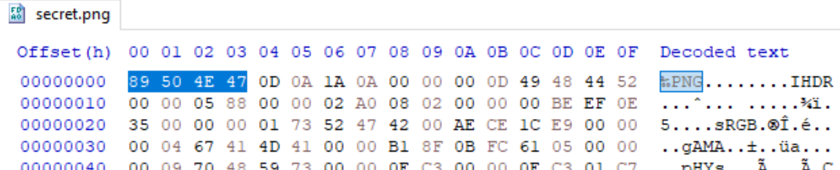

The image is:

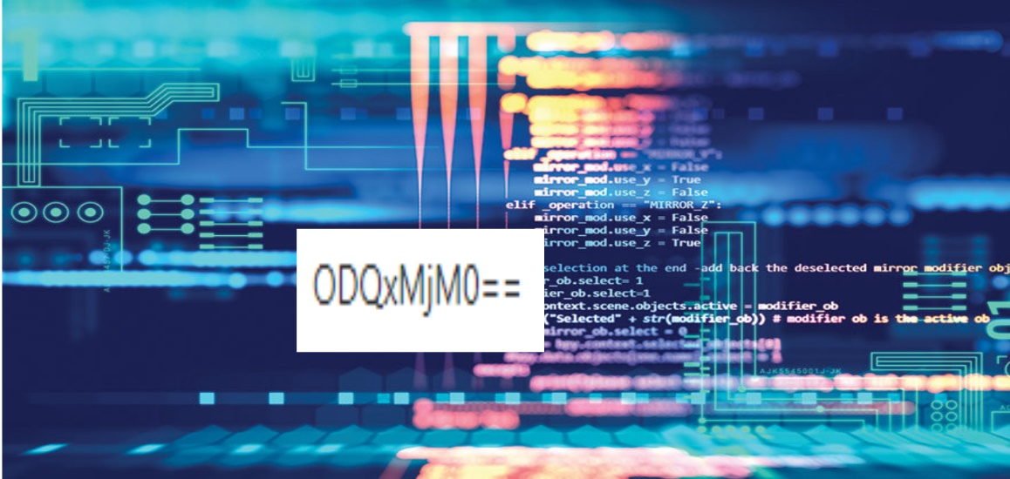

1. In the image I saw a combination of characters **ODQxMjM0==** which looked like an encoded text in **UTF-8** encryption. Therefore, I wrote this script in python using **base64** library to decrypt it:

import base64

def decrypt(s:str):

    # The function gets a string.

    # The function returns the string after decrypting it.

    return base64.b64decode(s.encode()).decode()

print(decrypt("ODQxMjM0=="))

The output: **841234**

1. Then, I thought about what to do with this number. I tried using it as the password to check if it’s possible to extract the **secret.rar** folder and it worked!
2. Afterwards, I ran the **secret.exe** file using cmd and it printed this text:

**>secret.exe**

**This software was valid up until 2011-11-11 11:11:11**

This output led me to